Migration bug fixed

1. What is this bug ?

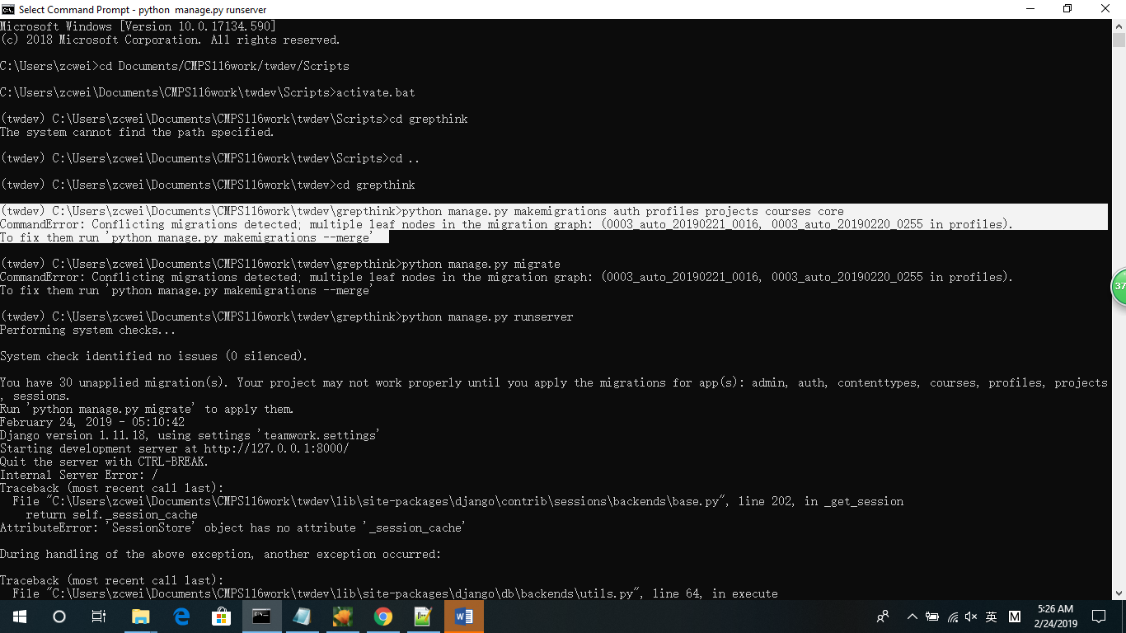

This bug will let user can not open the web, it will give them this error

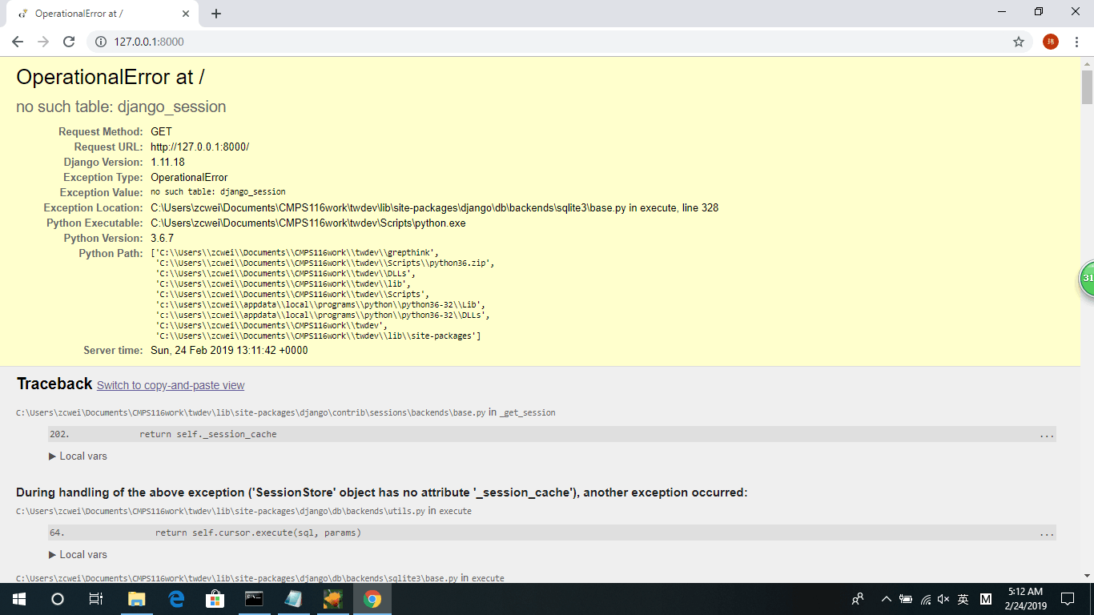

1. How to fix this bug?
2. Delete the file as below, restart the laptop and then type these three command lines again

python manage.py makemigrations auth profiles projects courses core

python manage.py migrate

python manage.py runserver



1. If this way not work, use the db.sqlite3 from your old version ( work version ) code to replace this db.sqlite3 and then type these three command lines again

python manage.py makemigrations auth profiles projects courses core

python manage.py migrate

python manage.py runserver